**ONLINE STUDENT FEEDBACK SYSTEM**

1. **Introduction**

The **Online Student Feedback System** is a webbased application designed to facilitate the collection and analysis of student feedback on academic courses, instructors, and educational programs. The system aims to provide a convenient and secure platform for students to express their opinions and suggestions, enabling educational institutions to improve the quality of education and enhance the overall learning experience.

* 1. **Purpose:**

This document gives detailed functional and nonfunctional requirements for online student feedback system. The purpose of this document is that the requirements mentioned in it should be utilized by software developer to implement the system.

* 1. **Purpose:**

This system allows the students to provide quick feedback which is provided by collage staff. The feedback report is generated and which is checked by HOD’s. He can view grade and grade obtained to the lecturers.

* 1. **Overview:**

This system provides an easy solution to collage staff and students for maintaining feedback related to collage staff and infrastructure, facility.

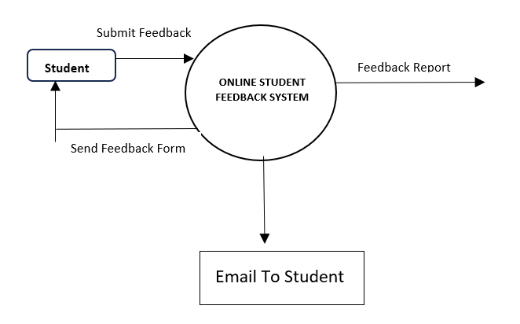

1. **Requirement Analysis and specifications**

Here we aimed to design the online web application for giving the feedback about the lecturers, particular subject, etc. by students to teachers. The system is supposed to be used as a subsystem in a large universities, school and colleges. In addition to that we also provide the rating system due to which the student will rate the teacher based on his/her teaching, we also provide the interactive user interface for student and teacher

### 2.1 Software Requirements

**Web Server:** The platform is going to be hosted on the web with php as back-end.

**DBMS:** All the data will be stored in structured tables which will be implemented using MySQL, an open source relational database management system.

**Development:** For development phase of our system we decided again on php. Our development platform will be .php and we are planning to use the following tools and languages.

* Php, MySQL programming language for main development
* HTML, CSS, JavaScript is used to improve the front-end and user experience of the website.

**Other Development Software:**

* Windows 10 operating system
* MS Office and Google docs for reports or any other documents.

### 2.2 Hardware Requirements

**Web Server:** We need a reliable web server for our system. This machine must be fast and must show high performance in all situations. At least 512MB RAM and Pentium4 2000MHz processor seems to be the minimum requirements for this machine. Any IBM, HP machine can be selected for this purpose.

**Database Server:** Since our system requires a huge amount of data to be stored, we will need an extra machine that will serve as a database. At least 40GB storage capacity is needed for this system. And this machine must also be a high performance machine. An IBM machine like xseries 382 may be a suitable choice for this purpose.

**3. ER Diagram**

### Database Design

This ER diagram represents the model of Online Feedback System. The entity relationship diagram of Online Feedback system show all the visual instruments of database tables and relationship between Student, Teacher, Feedback and Admin. It used structured data and define relationship between structured data groups of online feedback system functionalities. The Relations are Adds, Manages, Views etc.

The Entities involved in the ER-diagram are – (1) Admin.

1. Teacher
2. Student
3. Feedback

**TABLE DESCRIPTION**

#### (1) ADMIN

|  |  |  |  |
| --- | --- | --- | --- |
| SR. NO. | ATTRIBUTE NAME | ATTRIBUTE MEANING | ATTRIBUTE VALUE |
| (1) | Id | Admin’s id | Varchar(10) |
| (2) | Password | Admin’s Password | Varchar(30) |

1. **TEACHER**

|  |  |  |  |
| --- | --- | --- | --- |
| SR. NO. | ATTRIBUTE NAME | ATTRIBUTE MEANING | ATTRIBUTE VALUE |
| (1) | Id | Teacher’s id | Varchar(10) |
| (2) | Password | Teacher’s Password | Varchar(30) |
| (3) | Mobile | Mobile number of teacher | Varchar(11) |
| (4) | Designation | Teacher’s Designation | Varchar(10) |
| (5) | Sem | Semester the teacher is teaching | Int(10) |
| (6) | Email | Email id of teacher | Varchar(50) |
| (7) | Name | Teacher’s Name | Varchar(50) |

1. **FEEDBACK**

|  |  |  |  |
| --- | --- | --- | --- |
| SR. NO. | ATTRIBUTE NAME | ATTRIBUTE MEANING | ATTRIBUTE VALUE |
| (1) | Id | Feedback’s id | Varchar(10) |
| (2) | T_id | Teacher’s id | Varchar(10) |
| (3) | Stu_id | Student’s Id | Varchar(10) |
| (4) | Type | Feedback Type | Varchar(10) |
| (5) | Qn1 | Response of Question 1 | Enum (‘1’,’2’,’3’,’4’,’5’) |
| (6) | Qn2 | Response of Question 2 | Enum (‘1’,’2’,’3’,’4’,’5’) |
| (7) | Qn3 | Response of Question 3 | Enum (‘1’,’2’,’3’,’4’,’5’) |
| (8) | Qn4 | Response of Question 4 | Enum (‘1’,’2’,’3’,’4’,’5’) |
| (9) | Qn5 | Response of Question 5 | Enum (‘1’,’2’,’3’,’4’,’5’) |
| (10) | Suggestion | Any personal suggestion the student want to give to the teacher. | Varchar(200) |

1. **STUDENT**

|  |  |  |  |
| --- | --- | --- | --- |
| SR. NO. | ATTRIBUTE NAME | ATTRIBUTE MEANING | ATTRIBUTE VALUE |
| (1) | Id | Student’s id | Varchar(10) |
| (2) | Password | Student’s Password | Varchar(30) |
| (3) | Mobile | Mobile number of Student | Varchar(11) |
| (4) | Sem | Semester of student | Int(2) |
| (5) | Class | Branch of the student | Varchar(20) |
| (6) | Email | Email id of Student | Varchar(50) |
| (7) | Name | S tudent’s Name | Varchar(50) |
| (8) | Gender | Student’s gender | Enum (‘male’,  ’female’,’other’) |
| (9) | Img | Student’s image | Varchar(30) |
| (10) | Dob | Student’s date of birth | time |

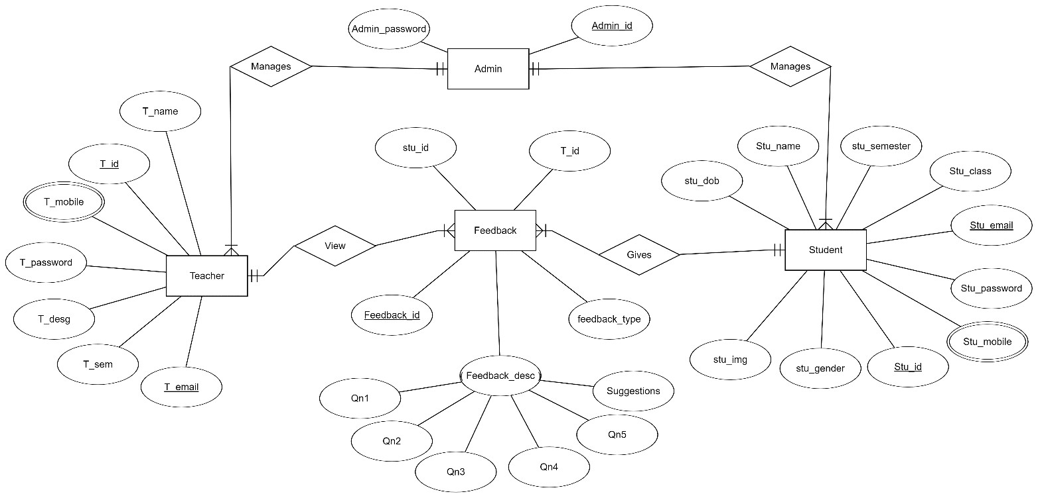

#### 3.2 Relational Database design

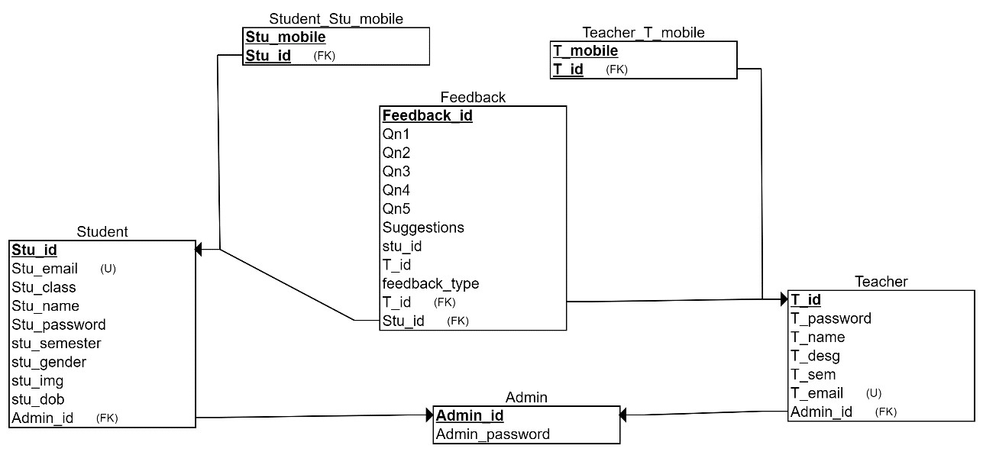

**Relational schematic diagram for Online Feedback System**

**3.3 Constraints in relation Schema:**

Give all the types of constraints with explanations that you have used for your project. For example:

* Key Constraints

|  |  |  |
| --- | --- | --- |
| Relation | Primary Key | Foreign Key |
| Student | Id |  |
| Teacher | Id |  |
| Feedback | Feedback_Id | T_id  Stu_id |
| Admin | Id |  |

* Cardinality Ratio

|  |  |  |  |
| --- | --- | --- | --- |
| Relation | 1:1 | N:1 | M:N |
| Manages  (Admin , Teacher) | No | Yes | No |
| Manages  (Admin, Student) | No | Yes | No |
| Gives (Student, Feedback) | No | Yes | No |
| View  ( Teacher, Feedback) | No | Yes | No |

**EXPLAINATION**

In Online Feedback System there are 4 entities Admin, Student, Feedback and Teacher.

##### (1) Admin

The Admin can add teacher and can view the feedback given by the student. In admins relation schema admin’s id is primary key. The relationship between Student entity and teacher entity is ‘manages’. Admin has 1:N cardinality ratio with both Teacher and Student. Admin can add many teacher and views feedback of many student.

##### (2) Teacher

Teacher can view the feedback given by the student. In teacher relation schema teacher’s id is the primary key. The relationship between teacher entity and feedback entity is ‘Views’. Teacher had 1:N cardinality ratio with Feedback entity. Teacher can view feedback of many student but, only feedback given to that particular teacher. One teacher cannot see the feedback of other teacher.

##### (3) Student

Student can give feedback to the teacher. In student relation schema student’s id is the primary key. The relationship between student and feedback is ‘gives’. Student has 1:N cardinality ratio with feedback entity. One student can give feedback to many teacher. A student can only give feedback to teacher belonging to same branch and semester.

##### (4) Feedback

Student’s feedback is stored in the feedback entity. In feedback entity feedback_id is the primary key, teacher_id and student_id is the primary key. Feedback entity gives the information about what is the feedback given to a particular student by a particular student. It relates student entity to teacher entity.